How to Reduce Admission forms MS Word File Size for Emailing to Head office?
Step-1
Open MS Word 2007
Step-2
Open Admission Forms MS Word File & Select one Admission Form Picture
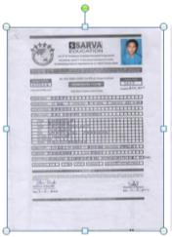
Step-3
After selecting one Admission Form Picture- See Menu war & Click on Format
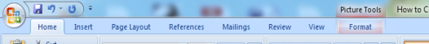
Step-4
After Clicking on Format, now click on Compress Pictures
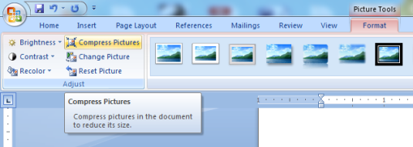

Step-5
After Clicking Compress Pictures, A Dialog Box will appear, Click on Options
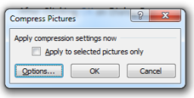
Step-7
After Clicking on Options, a new Compression settings Dialog Box will appear, select (Tick) both compression options & in target output section select E-mail & click OK (See below mentioned dialog box & select option accordingly)
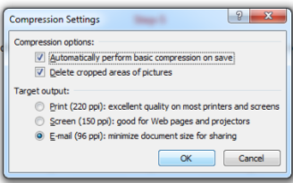

Step-8
After Clicking OK, Save MS Word File & Check reduced file Size & attach the same in your mail
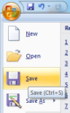
Note: For emailing MS Word file size must be below 25 MB. If still your file is heavy then create 2 or 3 MS word files.

