Sample of Total Student’s Admission list & Scan Admission Form
To be submitted to HO via Email in MS Word File Format only

(Edit Below Mentioned Table & Enter Your Student Name, Father Name Etc. As Shown In Table Given Below)

Admission List: Batch-1

Sr. No. | Student Name | Father Name | Course | Duration | Join  date | Valid  Up To | Session/  Batch | Roll. No | Student Mob. No. | Regd  Fee
1 | CHETNA KAPSE | GULAB RAO KAPSE | CCFA | 3 Months | 08/04/2019 | 30/06/2019 | Apr. 2019 To June, 2019 | 393801 | 0000000000 | 255
2 | KHUSHABOO PANDEY | GOPAL PANDEY | DCFA | 6 Months | 12/04/2019 | 30/09/2019 | Apr. 2019 To Sep. 2019 | 393802 | 0000000000 | 375
3 | ANJU CHOUHAN | MUKESH CHOUHAN | HDCS | 1 Year | 20/06/2019 | 30/05/2020 | June 2019 To May. 2020 | 393803 | 0000000000 | 495
4 | DEEPAK SHARMA | SUNIL SHARMA | HDCS | 1 Year | 20/06/2019 | 30/05/2020 | June 2019 To May. 2020 | 393804 | 0000000000 | 495
5 | ANKUR SINGH | SHAILENDRA SINGH | HDCS | 1 Year | 20/06/2019 | 30/05/2020 | June 2019 To May. 2020 | 393805 | 0000000000 | 495
6 | MEHARBAN PRAJAPAT | RAM PRASAD PRAJAPAT | HDCS | 1 Year | 20/06/2019 | 30/05/2020 | June 2019 To May. 2020 | 393806 | 0000000000 | 495
7 |  |  |  |  |  |  |  |  | Total Fee Paid to Head Office | 2610
8
9
10
For Adding/Inserting More Number of Students- Add/Insert New lines- After Sr. No 10 line- in above shown table.

Date of Submission Admission List & Form | 06-07-2019 | Paid By (Online Banking/Mobile Banking/NEFT/RTGS) | ONLINE BANKING (Phone pay) | 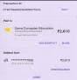  Paste Payment Transfer Receipt or Screen shot here
Centre Name | Rakesh Sir Accounts Classes and Computer Workshop | Write the name of our Bank A/c & A/c No. Bank Branch Name with IFSE Code. In which you have transferred Money. | PUNJAB NATIONAL BANK, , A/CS NO. 00000000000000, IFSE-PUNB0154100
Centre Address | St. No.2, Sector No.3, Indorama, Pithampur, Dhar (MP) | Date & Time of payment transfer | Date: 06-07-2019 Time: 09:52 AM
Centre Code | 3938 | Write the name of your Bank A/c & A/c No. Bank Branch Name with IFSE Code. From where you have transferred Money. | UNION BANK OF INDIA , SAGORE KUTI, 000000000, IFSE UBIN 0545287
Total Registration Fee Paid to HO. | 2610/- | Mention Payment Receipt no./UTR No./Transaction ID No. | TRANS ID P907060952364300575316

Scan Admission Forms: Batch-1

(Delete below mentioned Sample Scan Admission Forms & Paste your all students Roll numbers-wise good quality Color Scan Admission Forms along with applicable academic certificate as per eligibility of courses)

Roll No: 393801

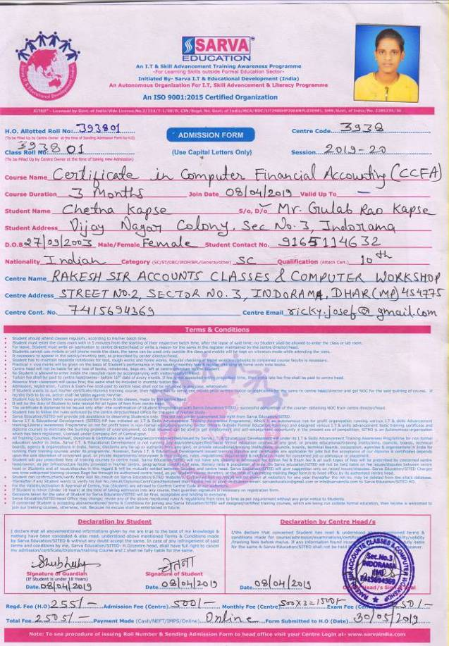
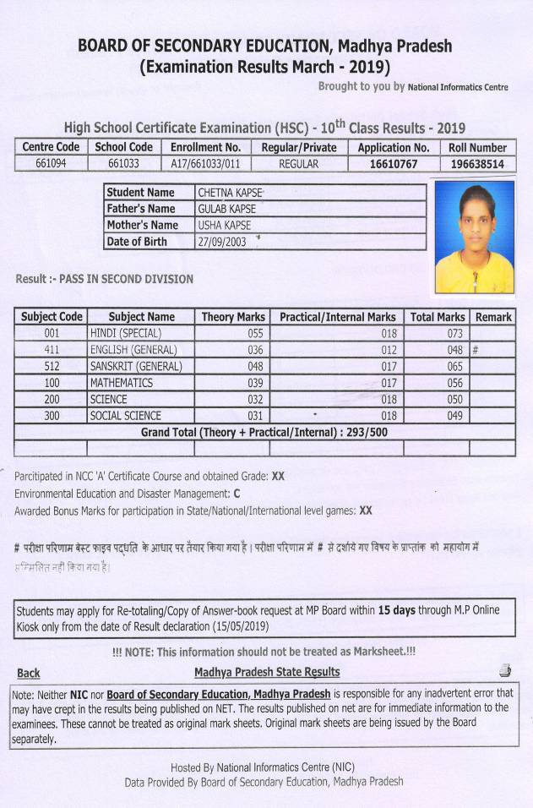

Roll No: 393802

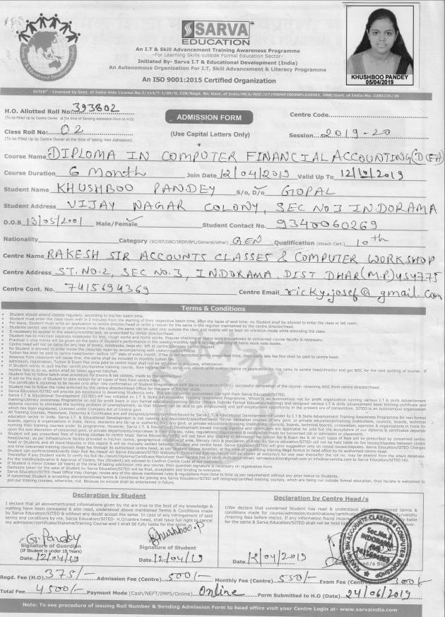

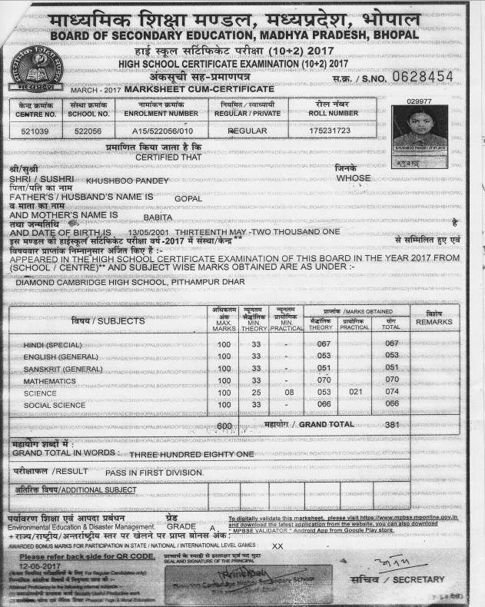

Roll No: 393803

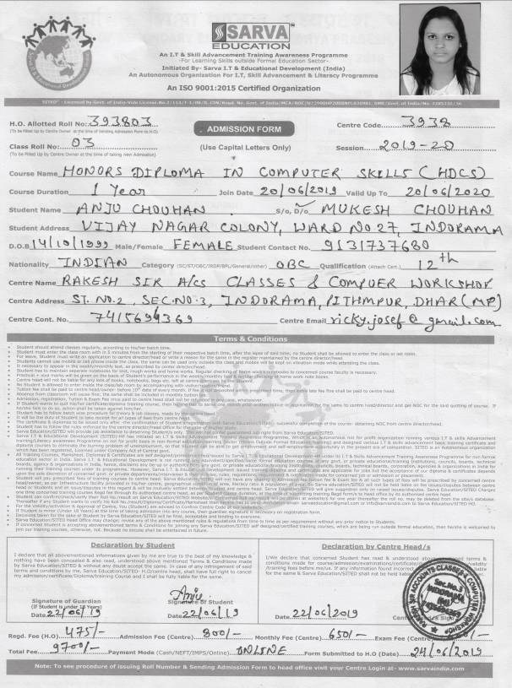

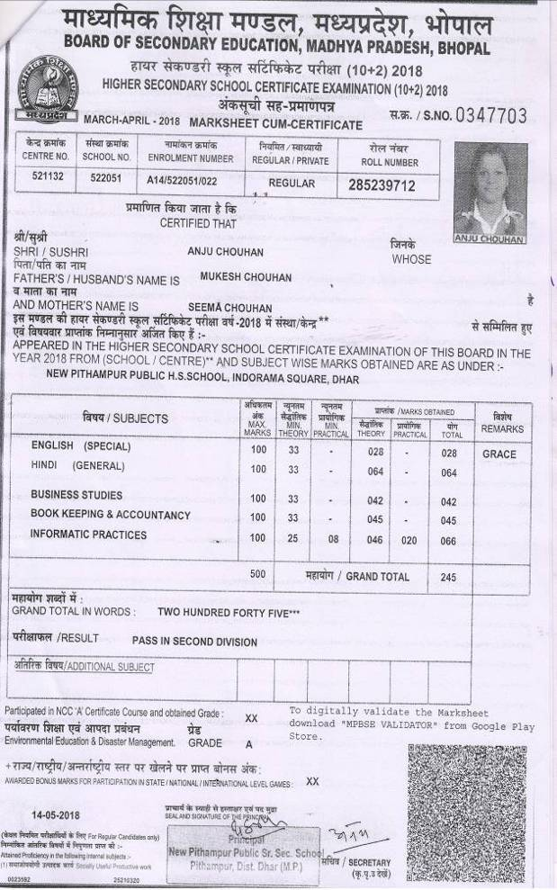

Roll No: 393804

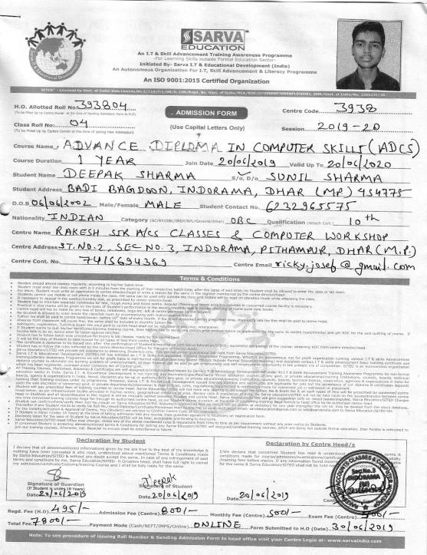

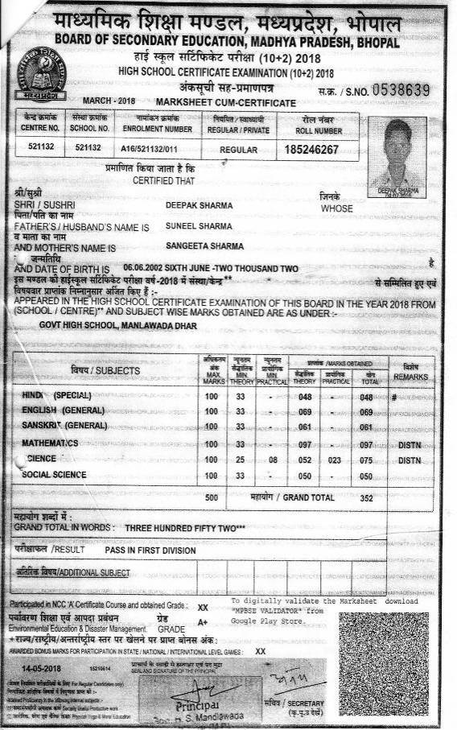

Roll No: 393805

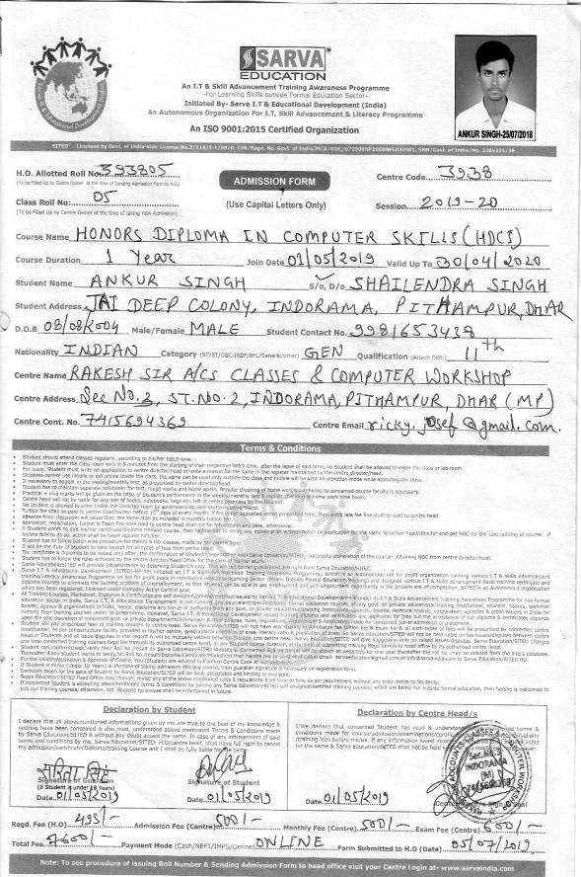
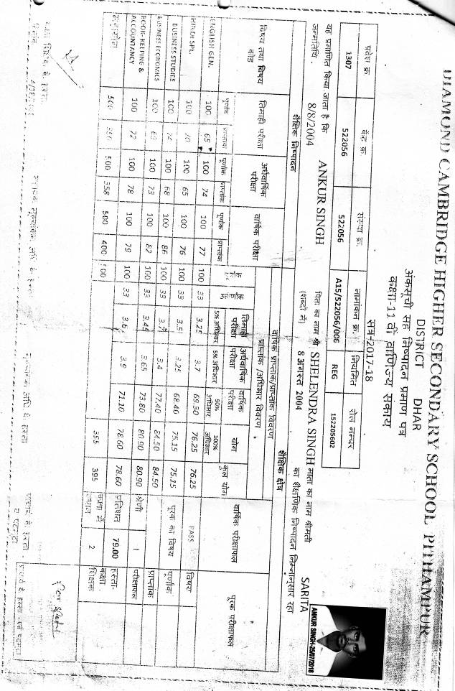

Roll No: 393806

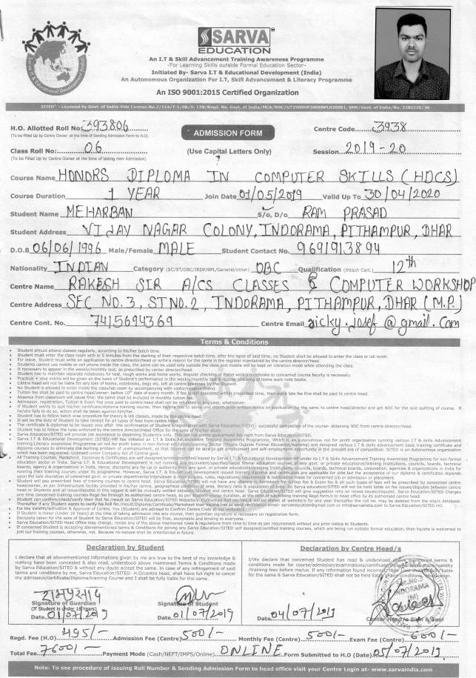

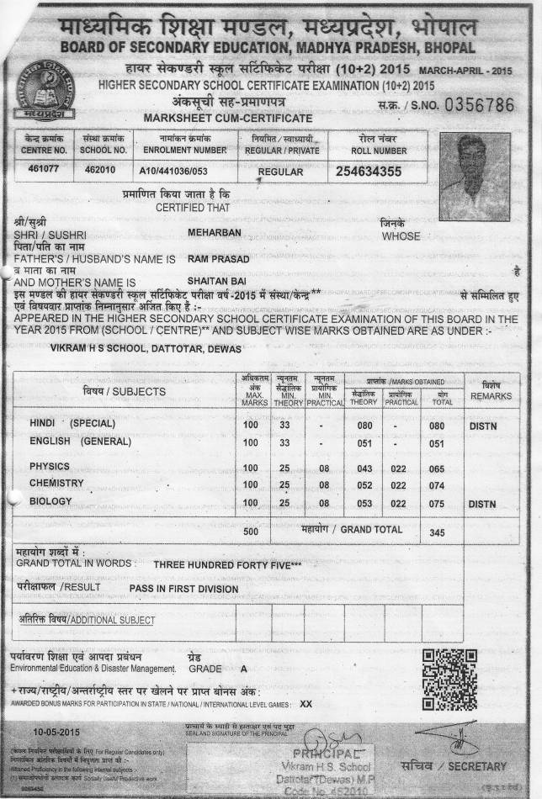

Please Also Note Following Steps-
Step.1:- Procedure for Issuing Roll Number Series on Admission Form:-
Procedure for Issuing Roll Number Series on Admission Form:-
There are two types of Roll Number Series- (1) Centre Class Roll Number Series. (2) Head Office Roll Number Series.
(1) Centre Class Roll Number Series- At the time of taking Admission in your centre, Start Class Roll number series on Admission form, from: 01/CR, 02/CR, 03/CR, 04/CR, 05/CR, 06/CR, 07/CR, 08/CR, 09/CR, 10/CR, 11/CR,...…..Continue this series for next Admissions.
(2) Head Office Roll Number Series- Head Office Roll Number Series will be written by you on Admission forms, at the time of sending admission forms batch along with total of student Regd. Fees details by email to head office, in following way- For Example: Suppose your Centre Code is 3938, then head office Roll No. series will start from 393801, 393802, 393803, 393804, 393805, 393806, 393807, 393808, 393809, 393810, 393811, …...Continue this series for next Admission batches & after sending admission form batch to head office by email, you have to add online concerned batch head office Roll numbers series in your center login panel
Centre head/owner will keep hard copies of admission forms in his/her record & send email of Scanned copies of admission forms batch in Above mentioned MS Word Files along with Registration fee payment transfer details.
Admission forms without Regd. fee payment receipt or payment transaction ID or UTR number will not be accepted.
Step.2:- How to Compress or reduce above mentioned Scan Admission Forms Size for Emailing to Head Office?
Answer- 1. Copy & Paste given below docx file link in your internet browser-
https://www.sarvaindia.com/uploads/1000119.docx
2. Or Copy & Paste given below mp4. Video link in your internet browser & Watch Video –
https://www.sarvaindia.com/uploads/1000120.mp4
Step. 3:- After, Adding, Compressing your Students details in Admission list & pasting Scan Admission Forms in this MS Word File, Now send the same at head office Email ID Address- sarvaeducation@gmail.com. Do not Create PDF files for emailing. We require only same MS Word docx file.
****************************************************************************************************************************************************************
Note-1:- For Taking Admission in Diploma Courses- Eligibility is 10th Or +2 Or Graduation (Check Courses link at www.sarvaindia.com). As per Diploma courses eligibility, you can attach/paste Scan copy of 10th or +2 or graduation academic certificate copy with student admission form.

Note-2:- For Taking Admission in Certificate Courses- No Eligibility, you can attach/paste Scan copy of 10th certificate Or Aadhaar Card Copy Or School ID card copy along with student admission Form.

Note-3:- Student can take admission in two or three courses in same time- For this you have to fill up separate courses Admission forms along with issuing separates roll numbers. You have to pay head office registration fee separately for each course. On Admission forms- in courses duration column, you have to write morning batch or afternoon batch or evening batch with course duration, because same will be printed & mentioned by head office on concerned student certificates. After getting these certificates student has option to produce concerned course certificate as per concerned job requirements. To avoid competition in your area, do not advertise this admission system publicly. For latest modification or updation in above shown admission system always check Latest News & Read FAQs in your login panel.

Note-4:- Student has to fill up & sign Admission form in own writing. in future, If there is any legal issue or dispute & student signature does not match with the signature on admission form, then centre owner/head will be responsible for the same.

Note-5:- If Any student is below the age of 18 years, then his/her legal guardian (parents) signature required on admission form along with concerned student signature. In this case, It is the duty of centre head to take signature of guardian. If guardian signature found is not found on admission form then centre head will be responsible for the same.

Note-6:- Authorised Centre head has to sign admission form along with centre stamp. Incomplete Admission form will be rejected.

Note-7:- If you want to know Admission & Examination Session System then Visit your center login & Click on Download Forms.

Do not Copy Abovementioned Contents without Authorization of SITED, All Contents Copyrighted

FOR ANY LATEST UPDATION IN THIS SAMPLE FORMAT, ALWAYS READ
FREQUENTLY ASKED QUESTION NO.1 IN YOUR CENTRE LOGIN PANEL

